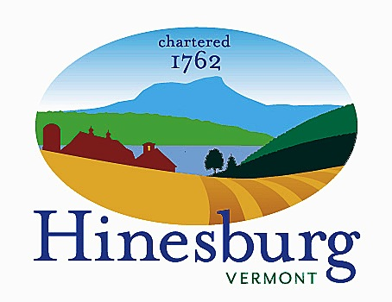

Affordable Housing Committee
Town of Hinesburg
10632 Route 116 Hinesburg VT 05461
802.482.2281 | hinesburg.org
Meeting Minutes – February 22, 2022
Remote Zoom Meeting – 7:00 PM
DRAFT – SUBJECT TO APPROVAL

Committee Members Present: Carl Bohlen, Emily Raymond, Mary Beth Bowman, and Dale Wernhoff.

Also Present: Cindy Reid (Cathedral Square), Tyler Labrie (Evernorth)

Public Present: Xander Patterson

The meeting came to order at approximately 7:00 PM.

Kelley’s Field II Update: Cindy Reid, Director of [Housing] Development for Cathedral Square, and Tyler Labrie, Associate Developer at Evernorth, gave us an update on the 24-unit expansion at the senior/disabled living community in the center of the village district. Since we last met at our 11/16/21 meeting, the project has received sketch plan approval from the Development Review Board and the design has been further developed. Nineteen of the units will be subsidized while the remaining five will be retail units. The Selectboard has voted in favor of the town applying for a Vermont Community Development Implementation grant to help with the costs of the addition. Cindy also said their general contractor has been able to provide cost estimates in real-time so they know where they stand with their budget. Water and wastewater allocations have been approved as well. Cindy asked if some of the town’s ARPA funds could be used to right down connection fees for affordable housing. We’ll need to check into that.

Accessory Apartment Video Follow-up Discussion: We’re thinking of organizing an informational panel with local general contractors to provide the public with more in-depth information on accessory dwelling units (ADUs). We were talking about setting something up for the fall when the suggestion was made to see if we could do something during the 4th of July parade. We need to come up with more concrete plans at our next meeting.

Town’s ARPA Funds for Housing Update: We’ve had several ideas on possible uses for the American Rescue Plan Act (ARPA) funds that will be provided to the town. These ideas include helping with connection fees, down payment assistance, a land bank, grants for ADUs, home improvements, and/or an affordable housing fund. We’ve decided to invite Alex Weinhagen, Director of Planning and Zoning for Hinesburg, to our next meeting to both brainstorm ideas and steer us towards what is feasible. We’ll also check in with Todd Odit, Town Manager, as to possible uses.

Inclusionary Zoning Change Update: We need to go before the Planning Commission to advocate for the town’s inclusionary zoning policies to apply to the bonus density of a project instead of the base density. Alex Weinhagen asked when would we like to meet with the commission. We all agreed to try to get this down before summer.

Hinesburg Center 2 Update: The Development Review Board (DRB) will be hearing the developer’s application at their 3/15/22 meeting. It will probably require at least a couple of meetings after that. Previously the two parts of phase 2 were going to be presented to the DRB separately but now they are going at the same time. This increases the number of affordable units that need to be supplied by eight. The developer would like to supply all of these additional units in one building but the Planning and Zoning Department is against that idea. We’ll see how this plays out.

Municipal Land Bank Discussion: Mike Loner, a member of the Selectboard and a local realtor, has testified before the state legislature in favor of a land bank as a potential tool in Hinesburg. The bank would purchase abandoned property, rehabilitate it, and sell it on the open market so the property gets back onto the town’s tax roll. The property would be bought at a tax sale, brought up to code, and then sold, with the profits providing funds for the next purchase. The land bank would be independent of the town and operate on its own. Carl is going to reach out to Mike to check on the status of this legislation.

Vermont Housing Committees Report by CVOEO: The Champlain Valley Office of Economic Opportunity (CVOEO) has put together a report on Vermont housing committees, based in part on a questionnaire that our committee and others responded to. Emily volunteered to review the report and provide feedback.

Homeowner Assistance Program: Alex sent Carl an email regarding a new homeowner assistance program that is being administered by VHFA. It’s designed to provide aid to homeowners who have faced financial hardships due to the Covid-19 pandemic. We need to check this out.

Recruitment of HAHC Member: Due to a recent resignation, our committee is down one member. If anyone is interested in joining, please let us know and we’ll walk you through the process.

Approve Minutes from January 25th: We reviewed the 1/25/22 minutes. Mary Beth motioned they be approved and Emily seconded. They were approved by voice vote.

The meeting was adjourned at approximately 8:30 PM.

Next Meeting –

March 22th – Topics to be determined; see agenda on the town website.

Respectfully submitted,

Dale Wernhoff
HAHC Secretary
Town of Hinesburg, Vermont | hinesburg.org

