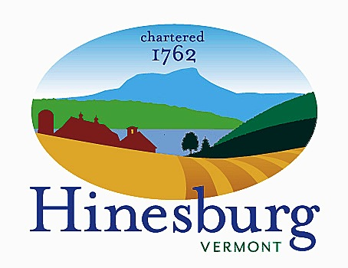

Affordable Housing Committee
Town of Hinesburg
10632 Route 116 Hinesburg VT 05461
802.482.2281 | hinesburg.org
Meeting Minutes – May 24, 2022
Remote Zoom Meeting – 7:00 PM
DRAFT – SUBJECT TO APPROVAL

Committee Members Present: Carl Bohlen, Mary Beth Bowman, Rocky Martin, and Dale Wernhoff.

Also Present: Brett Grabowski (Hinesburg Center 2 developer) and Mitch Cypes (Hinesburg Development Review Coordinator)

Public Present: Susan Rasmussen, Richard Andresen, and Dave Nagel

The meeting came to order at approximately 7:05 PM.

Hinesburg Center 2 Discussion: Brett Grabowski, developer of the Hinesburg Center Phase 2 project (behind Kinney Drugs), attended tonight’s meeting to discuss the quantity and location of the project’s affordable units. Phase 1 (Kinney Drugs and the surrounding buildings) required one affordable unit. Phase 2 requires nine affordable units for a total of 10 in both phases. Instead of placing all nine in the one suitable building in phase 2 (a 34-unit apartment building), Brett would like to have four in the new phase 2 building and six in phase 1. This would require converting five of the phase 1 units from market rate to affordable. The units will be a mix of two-bedroom, one-bedroom, and studio apartments. All ten of the affordable units will be rental units. Brett is not interested in providing affordable for-sale units because the economics of providing for-sale affordable units is tough to do from a builder’s standpoint. Rocky asked if Brett’s units meet the RBES stretch code. Brett said they meet Efficiency Vermont’s highest standard. This is slightly different from the stretch code. (See Energy Efficiency Zoning Changes Discussion below for further information.) Brett will provide us with a summation of the affordable unit type (2 BR, 1 BR, studio) and location (phase 1 or 2) this summer.

Accessory Apartment Promotion Discussion: Rocky talked to Phil Pouech about the availability of the Parish Hall at the United Church of Hinesburg for our fall accessory apartment forum. Phil will check into available dates. Rocky checked town meeting dates for any potential conflicts. It appears Thursdays are meeting-free except for the Town Forest Committee which meets on the second Thursday of the month. That leaves the first, third, and fourth Thursdays, which would be 10/6, 10/20, or 10/27 for the forum. Mary Beth came up with a working title: The ABCs of ADUs, How to Create an In-Law Apartment in Your Home or on Your Property.

Kelley’s Field II Update: Progress continues on the 24-unit addition to Kelley’s Field. Financing is lining up. The final plat application is scheduled to go before the Development Review Board at their 6/21/22 meeting. If all continues to go well, the developer, Cathedral Square, is hoping to break ground this October.

Inclusionary Zoning Change Update: There is no update on the Planning Commission’s review of the town’s zoning regulations. The Planning Commission will be addressing this later this summer.

Energy Efficiency Zoning Changes Discussion: Discussion continued from last month’s meeting regarding the Vermont Department of Public Service’s RBES stretch and base codes. Rocky is of the opinion to say no to requiring the stretch code. Carl and Dale agreed. During our discussion with Brett Grabowski (see above), Rocky tried to get out of Brett how much the stretch code costs in real-world numbers. Brett’s type of project doesn’t have a direct comparison of these figures. Brett did suggest that maybe an option would be to require the builder to price out the base code versus stretch code and present that to the purchaser, who can then decide if they want to spring for the upgrade or not. We all thought that was a pretty good idea.

Vermont Green Building Network June 1 Webinar: Dale joined the non-profit Vermont Green Building Network last year. Its mission is “to advance the environmental, economic, community, and health benefits of green design, construction, and building operation practices.” On 6/1/22 from 12:00 to 1:30 PM they are having a webinar titled “Affordable Housing in Vermont and Pandemic Response.” If anyone can, they are welcome to attend. Click here to register.

5/18/22 Select Board Meeting on ARPA Funds: Carl and Dale attended via Zoom (Mary Beth tried but couldn’t connect). Carl made our presentation for requesting $100,000 of the funds to go towards connection fee buydowns for affordable units. The Select Board hasn’t started any ARPA fund deliberations and doesn’t plan to until later this summer.

Approve Minutes from April 28th: We reviewed the 4/28/22 minutes. Rocky motioned they be approved and Mary Beth seconded. They were approved by voice vote.

The meeting was adjourned at approximately 8:10 PM.

Next Meeting –

June 28th – Topics to be determined; see agenda on the town website.

Respectfully submitted,

Dale Wernhoff
HAHC Secretary
Town of Hinesburg, Vermont | hinesburg.org

