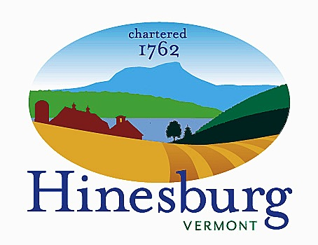

Affordable Housing Committee
Town of Hinesburg
10632 Route 116 Hinesburg VT 05461
802.482.2281 | hinesburg.org
Meeting Minutes – June 28, 2022
Remote Zoom Meeting – 7:00 PM

Committee Members Present: Carl Bohlen, Mary Beth Bowman, Emily Raymond, Rocky Martin, Xander Patterson, and Dale Wernhoff.

Also Present: Ben Avery (Haystack Crossing developer)

Public Present: Dave Nagel and Kerstin _

The meeting came to order at approximately 7:00 PM.

Haystack Crossing Discussion: Ben Avery, Vice President of Development for BlackRock Construction (developers of the Haystack Crossing project) attended tonight’s meeting to update the committee on the development’s progress. The project is scheduled for its final plat review at the Development Review Board (DRB) 7/19/22 meeting. The project will be in two phases with a total of 30 affordable housing units (AHUs). Phase 1 will have at least 20 units. 10% of the senior housing units (five units) will be AHUs. If everything goes well, they are a year away from breaking ground. BlackRock is hoping to work with Champlain Housing Trust to be able to make some of the AHUs available for purchase. Otherwise, they will be concentrated on rentals. The AHUs will vary in size from studio/1 bedroom/2 bedrooms/3 bedrooms/4 bedrooms and will be located throughout the project so they are part of the fabric of the community instead of segregated. Carl mentioned to Ben that in a previous meeting Ben had stated there would be 10 AHUs in the senior housing. Ben agreed that was the correct figure and that the remaining 10 units in phase 1 would be spread out throughout the project. Ben stated that he is now nine years into this specific project. The best way to provide affordable housing for developers is to decrease either the time or the money spent to get a project going. For example, he mentioned a project they are doing in Essex, VT. By providing 45 of 220 units as AHUs, they were able to eliminate having to apply for an Act 250 permit. Xander asked if there were any other ideas/options, but Ben stated incentivizing private developers to do AHUs is tough. Private developers need to make a profit (of any type or size) or they can’t stay in business.

Accessory Apartment Promotion Discussion: Rocky confirmed with Phil Pouech that the Parish Hall at the United Church of Hinesburg is available on 10/6/22, 10/20/22, and 10/27/22, all Thursdays. Xander can’t do 10/6 and we all thought 10/27 was too close to Halloween so we agreed on 10/20 for the date. We’ll need to meet with church officials ahead of time to go over the Wi-Fi requirements. Rocky is lining up speakers and will confirm the chosen date with the church. Emily will do marketing in September once we have the names of the participants. She is also going to put a “leave the date” notification on Front Porch Forum for 10/20/22 at 7 PM.

Housing Projects Update:
- Kelley’s Field II – They are still in need of funding so they won’t be breaking ground in October as they had hoped. Their meeting with the DRB went well, though.
- Hinesburg Center Phase 2 – The developer is contemplating going back to multiple phases instead of one final phase. The Planning and Zoning Department is waiting for an updated application.

Additions/Deletions to Agenda:
- Xander’s Comments on 5/24/22 Meeting – Xander was not able to attend our last meeting but wanted to provide the following feedback. At our 4/28/22 meeting, Xander proposed a $1000 per year property tax reduction as an incentive to help a homeowner upgrade from the Department of Public Service’s Residential Building Energy Standards (RBES) base code to the stretch code, which is more stringent. Alex Weinhagen, Director of Planning and Zoning, had concerns about how to implement this. Xander believes we should not give up on exploring this idea. Another suggestion Xander has is there are sellable pollution credits, so why not tax credits? We’ll have to investigate this.
- Joint Meeting with Conservation Commission – The Hinesburg Conservation Commission is exploring a conservation and housing fund and would like our committee to get involved. We’ll have a joint meeting with them on Thursday, 7/21/22, to discuss the parameters. The proposal for a joint conservation fund will then need to go before the Select Board.
- Meeting Schedule for the Remainder of the Year – Our next meeting will be the joint meeting above on 7/21/22. We’ll take an August break, and then resume meeting on the fourth Tuesday of the month, so our following meeting will be 9/27/22.

Approve Minutes from May 24th: We reviewed the 5/24/22 minutes. Rocky motioned they be approved and Emily seconded. They were approved by voice vote.

The meeting was adjourned at approximately 8:15 PM.

Next Meeting –

July 21st – Joint meeting with Conservation Commission; see agenda on the town website.

Respectfully submitted,

Dale Wernhoff
HAHC Secretary
Town of Hinesburg, Vermont | hinesburg.org

