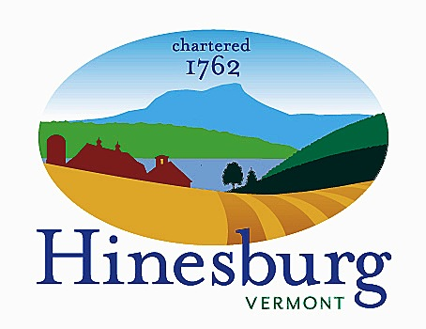

Affordable Housing Committee
Town of Hinesburg
10632 Route 116 Hinesburg VT 05461
802.482.2281 | hinesburg.org
Meeting Minutes – July 21, 2022
Remote Zoom Meeting – 7:00 PM
DRAFT – SUBJECT TO APPROVAL

Committee Members Present: Carl Bohlen, Emily Raymond, Rocky Martin, and Dale Wernhoff.

Hinesburg Conservation Commission Members Present: Kate Kelly, Bob Hyams, and Liz Doran

Public Present: Dave Nagel, Andrea Morgante, and Anne Sullivan

The meeting came to order at approximately 7:05 PM.

Potential Hinesburg Conservation & Housing Fund: This is a joint meeting of the Hinesburg Conservation Commission (HCC) and the Hinesburg Affordable Housing Committee (HAHC). It is to explore a combined fund shared by both groups for land conservation and affordable housing. Kate Kelly brought the meeting to order. Andrea Morgante provided background on how Hinesburg conservation funds traditionally obtained capital. The town would have a warning about voting for funds, along with a separately warned article. Town voters would then approve the funds. The assets in the fund would usually go towards the acquisition of land or towards fees. The typical outlay is between $5000 and $100,000. The first Vermont Housing & Conservation Board (VHCB) acquisition had a house on the property which they tried to convert to affordable housing but funding wasn’t available at that time.

Bob Hyams asked if land that is available for conservation is suitable for housing, or are they two different things? Andrea answered yes, some land is appropriate for both, but probably not multi-family units. A Habitat for Humanity project would be more suitable. Carl Bohlen added that if a combined fund had been available to the Russell Family Trust it would have worked for both conservation and housing.

It was agreed that both the HCC and the HAHC must decide how to proceed with a combined fund and then put that information before the Select Board. Andrea stated the HAHC and the HCC are two sides of the same coin, that being the price of land. Hinesburg residents have been very supportive of land conservation but we haven’t tested them yet regarding affordable housing. Carl said the HAHC has talked for years about a potential housing fund but didn’t want to go before the town, but maybe now is the time. The two groups should work together to come up with ideas on how to make a combined fund work. Bob believes the town would think affordable housing is tangible and would support it.

Andrea mentioned affordable housing units (AHUs) can be a variety of housing types. Bob asked if affordable housing has to be new? Carl responded it’s an AHU if there is a covenant to keep the property perpetually affordable. This could apply to new or existing housing. Andrea added the problem is it has to be affordable to own, and updating an older building to a good retrofit status costs money.

Bob inquired by making a joint fund, does that open more funding from other sources? Carl said a dual project is beneficial. You could go to both types of funding sources and get funds from both.

Ann Sullivan commented that from reading Front Porch Forum, many townsfolk are concerned with taxes. If we proceed with a joint fund, make the language as simple as possible so it’s clear to everyone. Andrea added it would be easiest to get support from the taxpayers if they can see tangible benefits. If a project came forward that fit both criteria, that would be the time to present it to the community.

Bob asked if a property by itself qualifies as an affordable housing project? Carl answered it could be land that looks suitable or it could be an abandoned building for conversion. As an example, Rocky Martin knew the previous owner of Kelley’s Field Senior Housing and knew they could add additional units. Cathedral Square, the current owners, didn’t have the funds to add any units at the time of purchase in 2014 but are currently in the process of adding 24 units. Carl said you could also do an option to purchase a property so you have time to figure things out.

Carl asked how do we come up with a first draft of the proposal to put before the Select Board? Dale Wernhoff stated he’s not sure how to move forward. Bob agreed, stating conservation is simpler while housing is more complicated. Kate determined we should make a draft for members to react to. Carl agreed to write up questions for the committee members to answer along with the draft after we shared tonight’s minutes between the two groups. Kate made the motion to adjourn and Dale seconded the motion.

The meeting was adjourned at approximately 8:05 PM.

Next Meeting of the HAHC –

September 27th – Topics to be determined; see agenda on the town website.
No date for another joint meeting of the committees was made.

Respectfully submitted,

Dale Wernhoff
HAHC Secretary
Town of Hinesburg, Vermont | hinesburg.org

