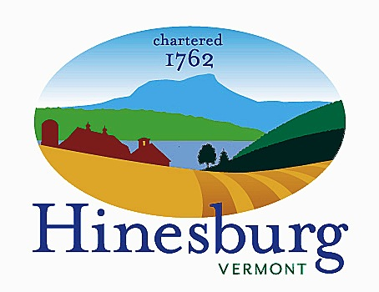

Conservation Commission
Town of Hinesburg
10632 Route 116 Hinesburg VT 05461
802.482.2281 | hinesburg.org

Hinesburg Conservation Commission Meeting Minutes
Tuesday, April 11, 2023 – 7:00 PM
Via Zoom:

- Call to order: Meg, Kate, Tobi, Liz present. 7:12 PM

- Additions/Deletions to agenda: None
- Public Comment for non-agenda items: None

- Updates: Geprags management – Tobi gave an update on Marc LaBarr and bird habitat management, Mowing update – we added a total of three extra mowing’s to our budget. ($1,980) Meg will check in with Wahls to make sure they know about it and that the budget works to get that done. Make sure they mow by end of June for Parsnip reasons. Also, they should set the blade as high as possible. Main field as well as around the pollinator garden. Ask about flexibility in case it happens early. Signs – defer to next time. Bridge – trails committee and permit people (DEC and wetland scientist). They need to weigh in to approve the bridge. Education: Tobi sent around a summary of education opportunities: Spring Ephemerals walk at Headwaters and Birding walk at Geprags. Advertise with Master Naturalist newsletter, Record, Citizen, Front Porch Forum. Meg is still working to schedule the Book Group for Our Better Nature. Maybe a beaver walk would be good. Also, maybe a talk on edible landscapes.

- Tobi reported on the Subdivision development training given by the State. We discussed the 30 By 30 proposal and the Town’s role in conserving land. Also discussed ideas around collaboration with other towns, based on intact forest blocks.

- Grants update: AVCC -- Bob applied for funding. We will wait to see what happens. Fish and Wildlife Watershed Grant – we did receive money for the Beaver Deceiver project. The beavers have put in a dam both above and below the road, so according to Skip Lyle, the beaver expert, we might not need the beaver deceiver. It makes sense to accept the funds and have Skip come out to assess the area. We might want to write a story about what happens with this project, to submit to local papers. Liz made a motion to accept the funding. Meg seconded. Unanimously approved.
- Discussion of new zoning regs proposed by the Planning Commission. Perhaps the CC should propose some kind of connectivity component to facilitate wildlife corridors. At this stage, support is more important than suggestions. Kate will write an email to Alex, expressing support and asking for corridor protection.

- Green Up Day schedule: We have that lined up.

- Review minutes of February 14 and March 14, 2022: February approved. Tobi made a motion to approve. Kate seconded. Unanimously approved.

- Nature Notes

- Adjourn 9:12 PM

