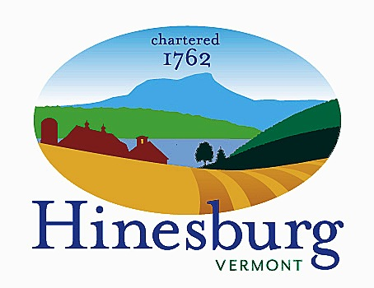

Economic Development Committee
Town of Hinesburg
10632 Route 116 Hinesburg VT 05461
802.482.2281 | hinesburg.org
Meeting Minutes – November 13, 2023 at 5:30
Town Hall – 1st floor Conference Room

Present: Melissa Levy, Will Patten, Travis Counter, Amanda Vincent, Stephen Gladstone, Natacha Liuzzi

- Call to order 5:30 PM
- Discuss partnership around banners
The HBPA was expected to attend, but unable. The EDC sees a partnership with the HBPA, Natacha’s group and the EDC to work toward a village banner project. EDC will ask the HBPA to talk about this with the Town and the Fire Dept.
Travis will check on the flagpoles.

- Budget
We discussed the need for a branding project. Will will reach out to Ted Brady at the VT League of cities and Towns. Melissa will reach out to Bristol CORE to learn more. This could be in partnership with the Planning Commissions, DRB, Town Commons Committee, etc. Better Places at ACCD may be a good source of funding.

- Annual report
We discussed the annual report. Melissa will draft and send around to the committee before it is due 12/15. We’ll talk about the new committee members, our RLF loans, the business forum and what’s coming.

- Town Forest Grant
Will to draft a letter.

- Forum on the budget
The Selectboard would like the EDC to encourage people to attend. We’ll work with HBPA on this. We suggested this for our next meeting – Dec. 11. Travis will check on Selectboard involvement and timing. Amanda will help promote.

- Follow-up and next steps from business forum.
Amanda will continue to check in with HBPA group in January.

- Discuss how to prioritize the Commons.
The estimated cost is $1 million. The Town would use $100,000 to do site work.
There is talk of instituting a 1% sales tax which would require a charter change, but would raise $250,000 a year.

- Adjourn 6:37 PM

