Recreation Commission
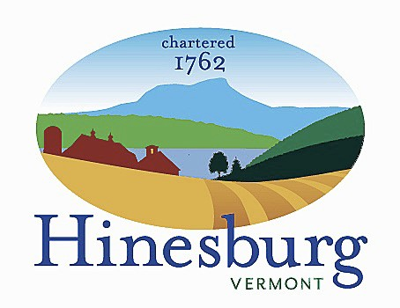

Town of Hinesburg
10632 Route 116 Hinesburg VT 05461
802.482.2281 | hinesburg.org

Recreation Commission Minutes – April 12, 2022
Members present via Zoom: Tom Giroux, Liam Powers Rodney Putnam & Mike Webb
Members Absent: Frank Twarog
Also present: Jen McCuin
- Call to order – Zoom launched and connected by 7:02 pm.
- Public Comment. None.
- Additions/Deletions
- Storage Facility designs by Mike and Liam are shared. Agree that two different designs were helpful and brought different perspectives. Much discussion occurred – including planning for future with bathrooms, plumbing, power, septic, storage, location, future adjacent development, spreading out pavilion, solar on roof might not be prudent based on location of fields, cost of construction, the option of cement block construction, etc. What are the next steps? Jen agrees to share plans and discussion with Town Manager for some insight and direction.
- Bleacher assembly project. Liam will contact Joe Bissonette to transport a set of bleachers to his shop. He acknowledges Joe’s generosity to store these bleachers for many years and will determine if Joe would like all of them removed at once. Liam also proposes building the first set of bleachers at his shop in a controlled environment.
- Tom confirms Jeff Glover, Doug Gunnerson and Hank White as July 4th Parade’s Grand Marshals.
- Adjourn at 8:37 pm.
- Next meeting is 5/10/22 at 7 pm with Zoom link listed on website.

Town of Hinesburg, Vermont | hinesburg.org

