Recreation Commission
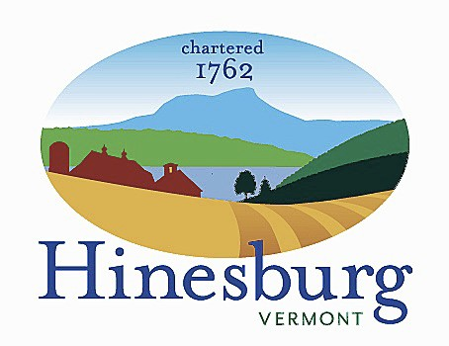

Town of Hinesburg
10632 Route 116 Hinesburg VT 05461
802.482.2281 | hinesburg.org

Recreation Commission Minutes – June 14, 2022
Members present via Zoom: Frank Twarog & Mike Webb
Members Absent: Tom Giroux, Liam Powers & Rodney Putnam
Also present: Jen McCuin
- Call to order – Zoom launched and connected by 7:05 pm.
- Public Comment. None.
- Additions/deletions. None.
- July 4th planning. Jen shares confirmed plans. Route 116 road closure paperwork, closure signs to be posted, GMCS security, Casella, P&P, Northstar Fireworks, food vendors. All costs have increased significantly this year. Did not find a band to perform prior show. Any suggestions? Confirms Tom Giroux is arranging parade transportation for Grand Marshals and judge selection. Jen confirms having tall orange cones to set up 30 yards north and south on Rte. 116 starting at 10 am per Frank’s concern to warn traffic slowing to enter of Buck Hill Rd. West entrance for parade line-up. Shares concern for police staffing for post fireworks traffic. Frank offers to contact Police Chief to see if there are alternate staffing options for that night such as Sheriff’s Dept.
- Concerts in the Park begins 7/13. Rodney Putnam to perform. Concert schedule available at www.hinesburgrec.com Jen away on 7/20. Season goes through 8/10.
- Bleacher assembly project. No update available.
- Pick-up youth and adult soccer. Mike confirms strong attendance. Jen updated site to include non-residents and appropriate youth ages to jive with grades 1-5. Jen confirms low numbers for Voltage Soccer Camp and may need to cancel.
- Adjourn at 8:04 pm.
- Next meeting is 7/12/22 at 7 pm with Zoom link listed on website.

Town of Hinesburg, Vermont | hinesburg.org

