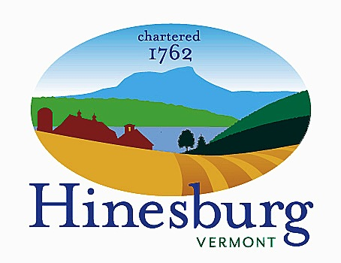

Economic Development Committee
Town of Hinesburg
10632 Route 116 Hinesburg VT 05461
802.482.2281 | hinesburg.org
Meeting Agenda – February 13, 2023 at 5:30
Town Hall – 1st Floor Conference Room

- Call to order 5:30 PM

- Additions/Deletions to agenda 5:30 PM

- Discuss RLF marketing next steps. 5:40 PM

- Discuss business interviews 5:45 PM

- Discuss Town Business Forum idea and next steps 6:00 PM

- Other business/Community input 6:15 PM

- Adjourn 6:30 PM

