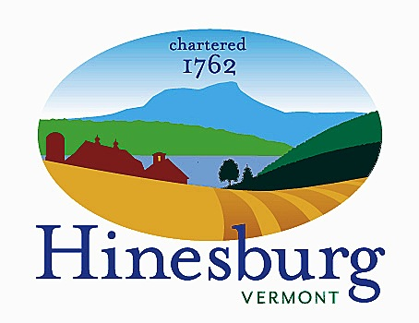

Economic Development Committee
Town of Hinesburg
10632 Route 116 Hinesburg VT 05461
802.482.2281 | hinesburg.org
Meeting Agenda – September 11, 2023 at 5:30
Town Hall – 1st floor Conference Room

- Call to order 5:30 PM

- Additions/Deletions to agenda 5:30 PM

- Follow-up and next steps from business forum. 5:40 PM

- Discuss how to prioritize the Commons. 5:50 PM

- Discuss recreation economy 6:05 PM

- Discuss RLF marketing next steps 6:25 PM

- Other business/Community input 6:25 PM

- Adjourn 6:30 PM

